Toolkit on Accessibility

Tools to apply universal design across premises and programs and promote access for all

TOOLBOX:

MISCELLANEOUS TOOLS

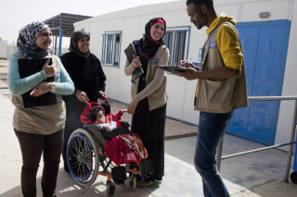

## 

Symbols of accessibility

To clearly indicate accessible spaces, a number of international symbols have been adopted that do not require knowledge of the local language. The table below shows a select sample of these highly recognizable graphics.

|  |  |
| --- | --- |
| **Symbol** | **Description** |
| **International Symbol of Accessibility** | International symbol of accessibility used for facilities, entrances, parking and premises (ISO 7001) |
|  | Accessible toilet – unisex, female or male (ISO 7001, in conjunction with other symbols) |
| Image result for ISO symbol for accessible elevator | Symbol for accessible elevator or lift |
|  | Accessible emergency exit, combining symbols for accessibility (ISO 7001) and emergency exits (ISO 7010) |
| **Braille  symbolLarge Print symbol** | Braille and large-print symbols indicate that alternative formats of books and information are available for people who are blind or have low vision |
| **Assistive Listening Systems** | Assistive listening system symbol shows that a hearing loop or FM system is available |
| **Sign Language Interpretation** | The two-hand sign language interpretation symbol can indicate that sign language interpretation is available for example for a meeting or event |
| **Closed Captioning symbol** | The CC (closed captioning) symbol indicates that events or media such as TV programmes, videos and films have closed captioning for people who are Deaf or hard of hearing |